
Development Request
Aria Systems
New Program Template Description

New Program Template Description

New Program Template

New Program Header
Product: | Aria 27
Module: | IC-PO
Customer name: | David Luke
Installed Modules: | AL, AR, AP, GL, IC, MA, PO, SO, RM
Parameters setting: | Extended Sizes -

.

Details Section
Existing Initial situation:
Further changes to the standard system to cater for bin locations in the following programs – (the current custom program nos are: 37816)

Physical Inventory – Inventory Locking – Issuing Style Components to PO cost sheets - Rebalance of Inventory and Allocated

Physical Inventory:

This needs to be amended as per the Inventory Adjustment program so that the user is prompted to enter a bin location after selecting the main location. The Bin location selected needs to be added to the main browse between “Description and Existing”.
So the new bin location file WHBINLOC should be used to show the existing inventory (if there is any) – if not he program should create a new WHBINLOC record as long as the hanging/flat and class rules apply to the bin location selected.

Inventory Locking:

When loading the main Inventory Locking Screen – there needs to be an extra column on the screen after description that says bin location. The screen then needs to load from the WHBINLOC file – an entry for each record and not the STYDYE file. There is already a CLOCATION field on the MDINVNTL file that can be used.

SO when the batch is posted then the WHBINLOC file has also to be updated along with all the other files.

Inventory Markdown Report

If the user selects the Print by Bin option then you need to print an entry for each WHBINLOC record and add a column at the start of the report to print the location

Issue Component on PO Cost Sheet:

When issuing Style Components in both Automatic and Manual Issue in the PO Cost Sheet program we need to able to nominate the Bin Location to issue the style components from.

Manual Issue –

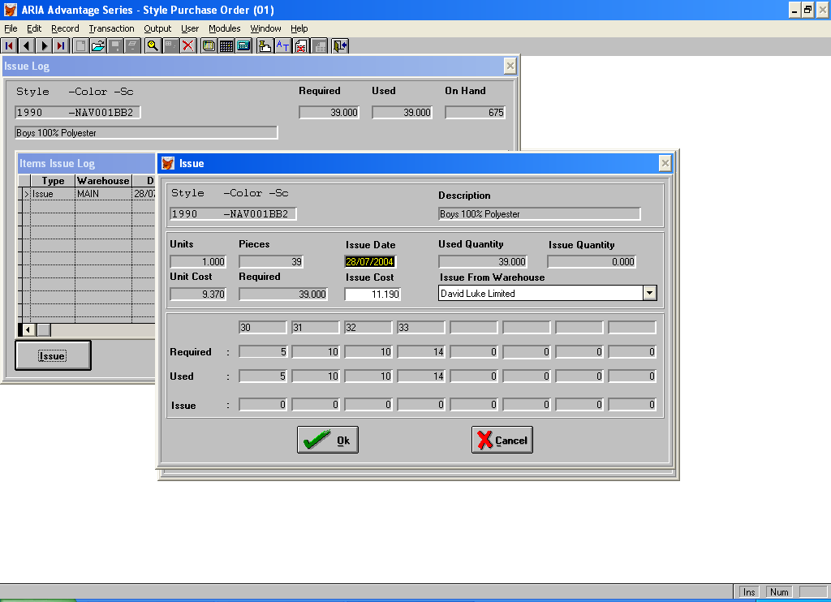

The items issue log screen should show an entry for each WHBINLOC record with a column added to show the bin location. SO when the line is selected – the quantities that appear on the next screen are only the quantities for that bin location. Also the On Hand calculation should be Inventory less Allocated.

Automatic Issue –

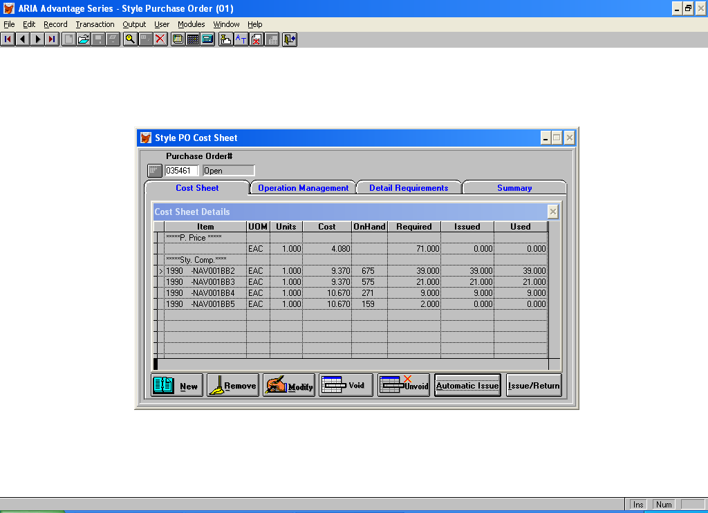

As you highlight each issue – you need to be forced to enter a bin location form an available list – and the on hand amount shown should only be from that bin location.

In both Manual and Automatic when saving you should update the WHBINLOC and a CTKTBOM record written for each bin location issued and a bin location field added to the CTKTBOM file for future reference – should the Issue be returned – so that it goes back to the same bin location.
.
Also in both cases the On Hand figure should be Inventory less Allocated.

Rebalance Databases:

The 2 rebalance options that need to amended are Inventory and Sales Order Allocation:

In order be able to rebalance the WHBINLOC file you will need to add the bin location to the Styinvjl file and create a Styinvjl record for each bin location transaction in the following programs:
Invoice Sales Orders, Direct Invoice, Credit Memo, PO receiving, Transfer Inventory, Inventory Adjustment, Physical Inventory, Issue Style Components,

When these changes are being done would it be possible to add the following 2 amendments:
PO Receipts - when a Receipt is being saved and no bin locations has been entered - instead of bringing up a message saying "No Bin Location has been assigned" - give the user the choice of either a) going back to enter them manually as now or b) pick a single bin location from a browse list of available locations for warehouse being received into - and use that bin location for the whole receipt.
Credit Memos - do the same as above on saving of a Credit Memo where the bin locations have not been assigned

